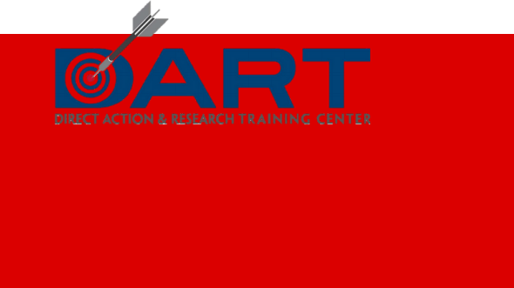
Researchto

Nov. 17 12:00 PM - Nov. 19, 2022 Noon C
ActionALTI

Register NOW!

Work with your organizer to register by the October 21, 2022 deadline.

Attendance Fee:
NO COST to CAJE Members
Includes Thursday dinner, Friday
l unch and dinner, AV, t rai n i ng
supplies, printing and coffee.
Hotel:
Radisson, Dayton, Ohio

$109.00 Per room per nig ht p lus any
applicable taxes and fees.
NO COST to You
Work with your organizer to reserve
your hote l room.

