
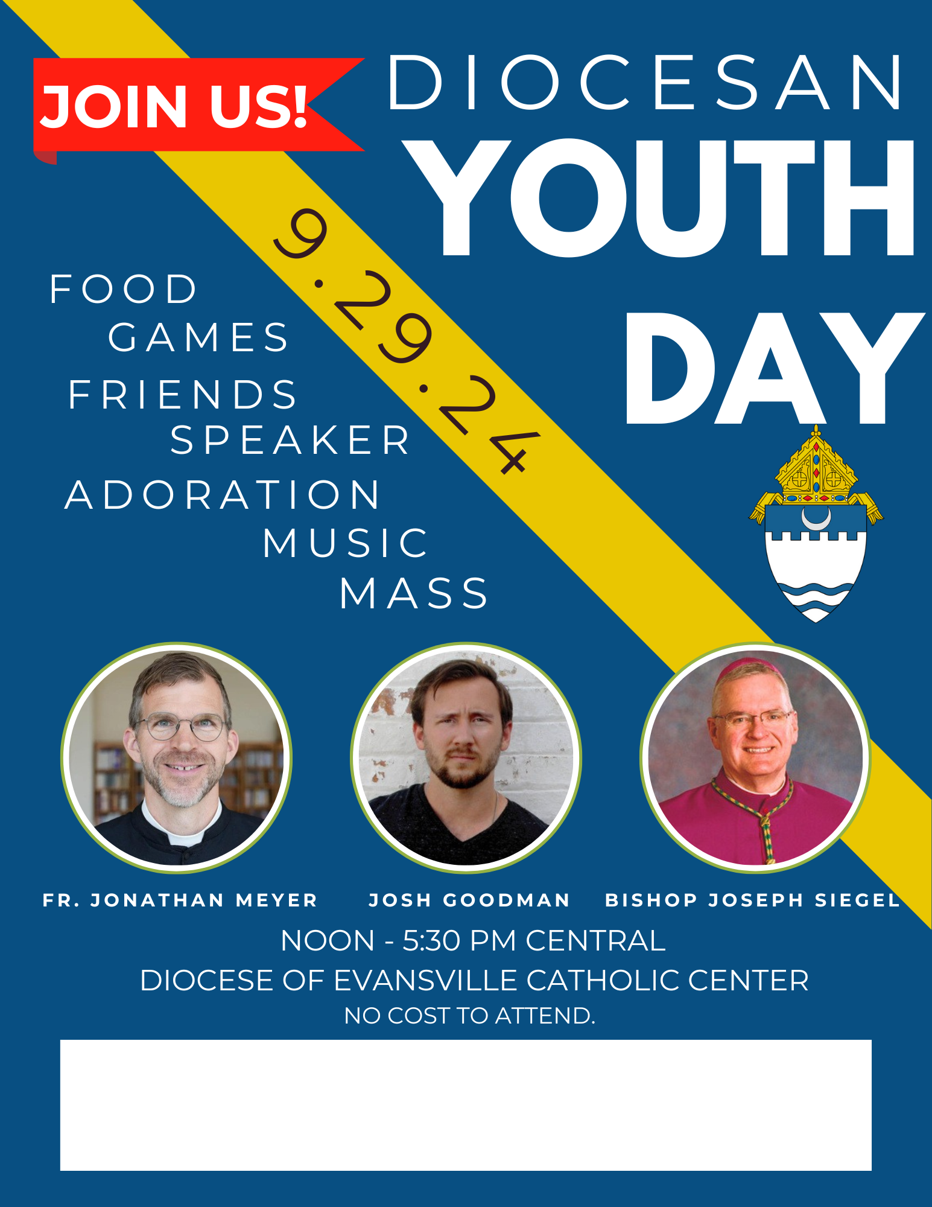
ALL HIGH SCHOOL YOUTH ARE INVITED!
You must register by Sept 12 through this QR
Or https://forms.gle/QU1P5cJvaupH7oFu9
Questions to wlovell@evdio.org

